Friday, November 20, 2020
1:00 – 2:00 PM
Online through Zoom
Registration Required! (Link Below)

Featured Speakers:
JEANNE MCPHEE
Doctoral Student in Clinical Psychology
College of Arts and Sciences
Impact of Race, Age, and Crime Type on Public Impressions of Juvenile Transfer of Female Defendants

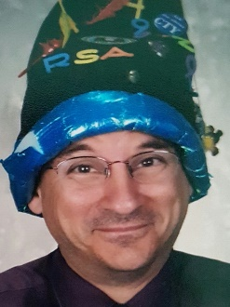
STEVE EARTH
Doctoral Student in Computer Science
College of Computing & Informatics
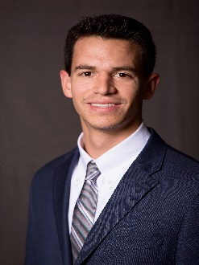
Evidence-Based Techniques for Preventing, Detecting, And Dealing with Cheaters in A Remote-Teaching Environment. Aka How I Learned to Stop Worrying and Love the Zoom
LUIS REBOLLAR TERCERO
PhD candidate in Chemical Engineering
College of Engineering
Another Benefit of Caffeine: Caffeinated Interfaces Enhance Hydrogen Electrocatalysis

Registration Link Here
For more information, please visit drexel.edu/graduatecollege

